You now have an account set up so that you can run reports, download reports, and set up accounts for other members of your team. You should have received an email with a one-time login allowing you to set your password.
Note: On rare occasions some users have seen an error stating ‘This page isn’t working’. If this occurs, please click on the ‘try cleaning your cookies’ link and follow the instructions on screen, then try the link again.
Once you have logged into the site you will be taken to your company’s page.
Note: the colour scheme may vary from that shown in the examples below

Running reports/syncing data
- Before you can sync your data you must first tick the box to confirm you have read and agree to the terms and conditions
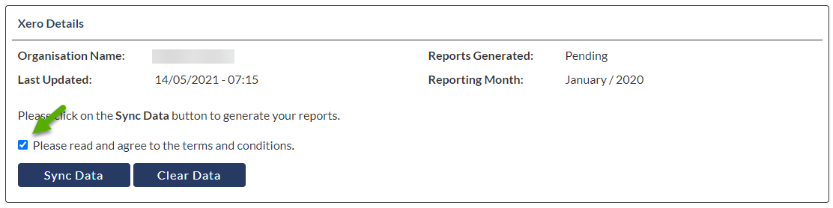
- Click ‘Sync Data’ in the bottom left of the page
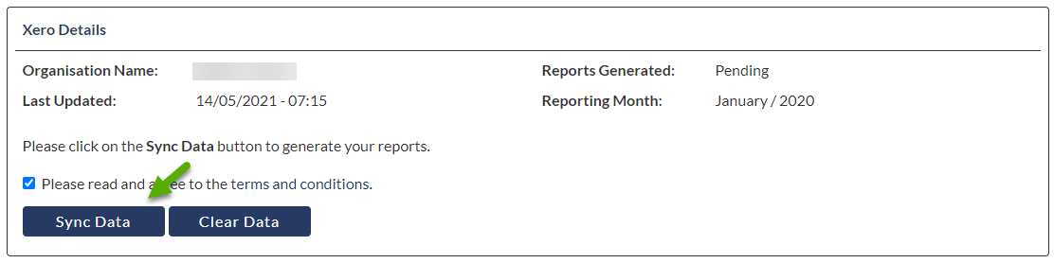
- You will receive an email with the subject ‘Your Financial and Management Reports have been updated’ once your reports are ready to download. Reports typically only take a few minutes to be generated but can take up to half an hour if there is lots of data, or if it is the first time your company has been synced.
Note: Please ensure that you only click the sync button once and do not click it again whilst the reports are being generated.
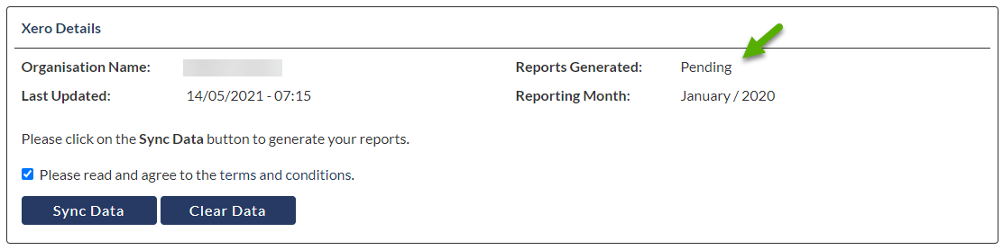

Downloading reports
1) Click on ‘View Reports’ at the bottom right of the page
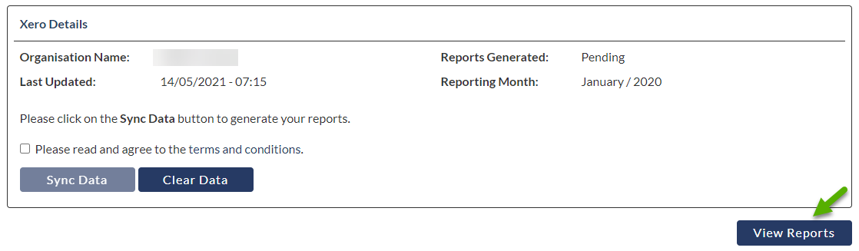
2) Click on ‘Download’ next to the report you would like to look at
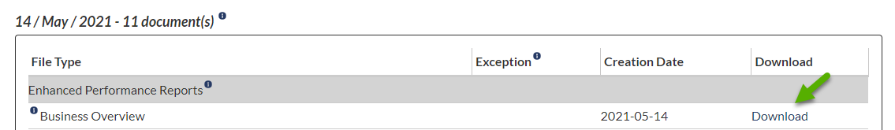

Create/edit User accounts
- Click on ‘Manage Users at the top right of the page
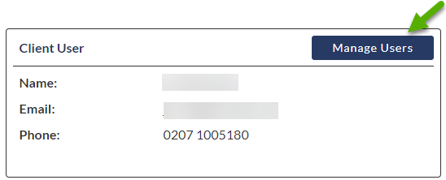
- To create a new user, click on ‘Create Client User’ in the top left of the page
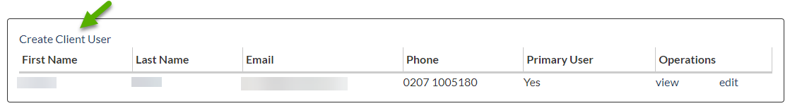
OR
To edit an existing user click on ‘Edit’ to the right of their name
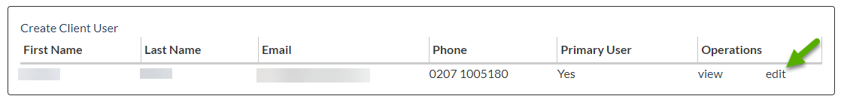
- Enter/edit the users details in the relevant areas
- Use the tick boxes to select the permissions for the user. The access these permissions will grant are detailed below:
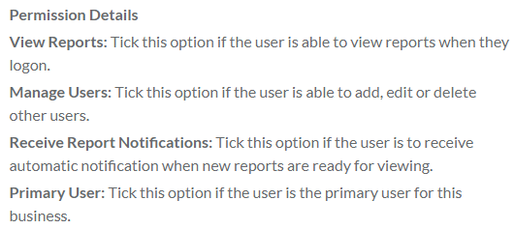
- Click ‘Save’ at the bottom left of the screen. This will trigger an email to new users with a link for a one-time login allowing them to set their password for future logins.
Note: On rare occasions some users have seen an error stating ‘This page isn’t working’. If this occurs, please click on the ‘try cleaning your cookies’ link and follow the instructions on screen, then try the link again.
Should you require any assistance please email ticket@vfd-pro.com

